 Task on s3:

*Create s3 bucket and upload some objects to s3.*

*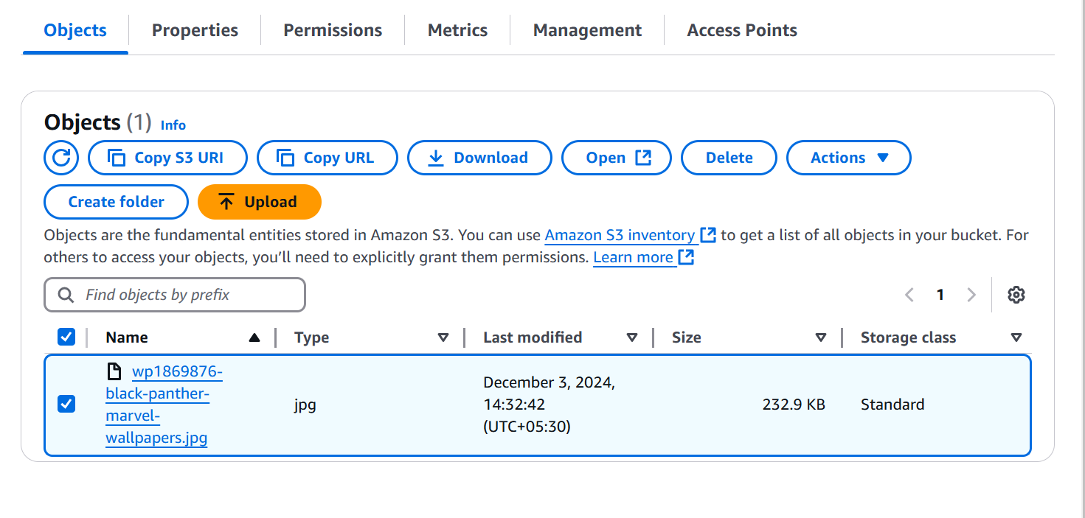*

**

*Deploy static website in s3 bucket.*

*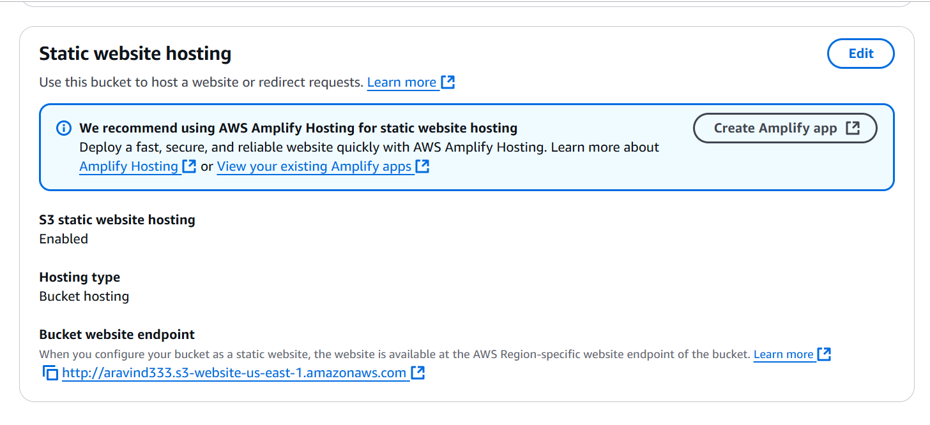*

*Enable cross region replication on s3 buckets.*

*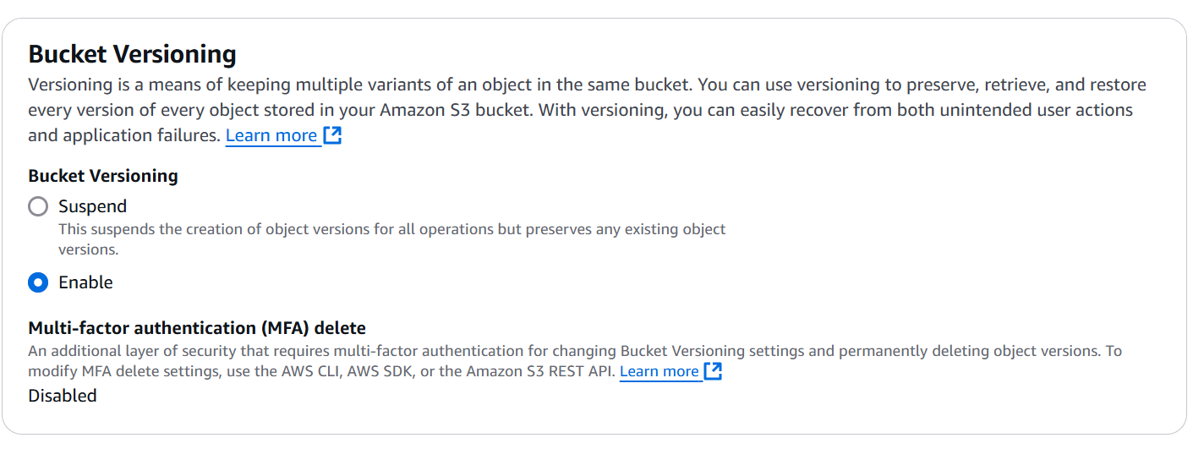*

*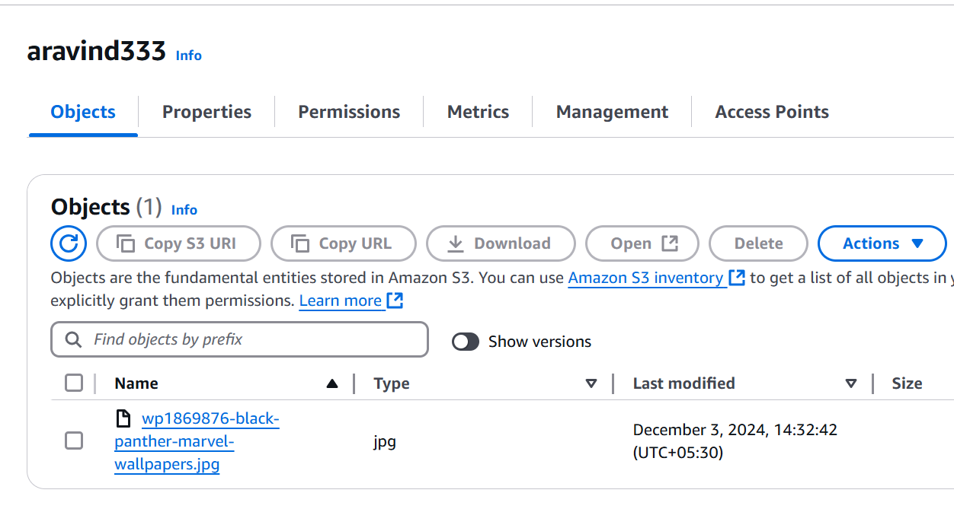*

*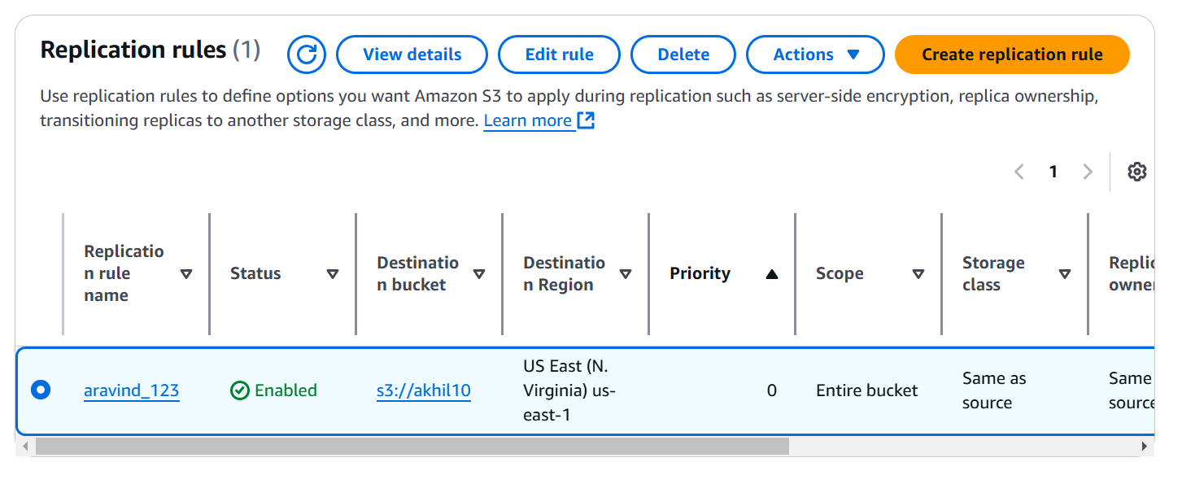*

*Configure bucket policy,only Admin user can see the objects of s3 bucket.*

*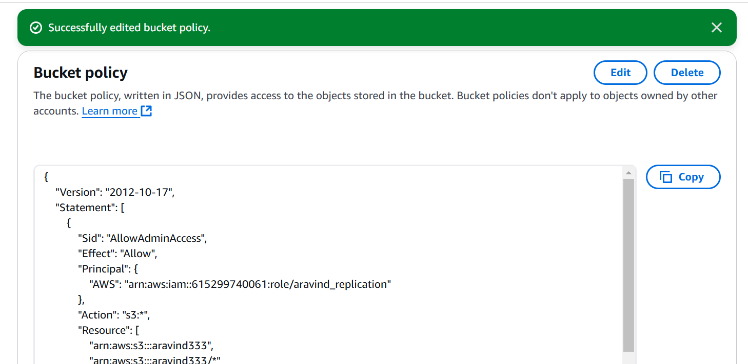*

*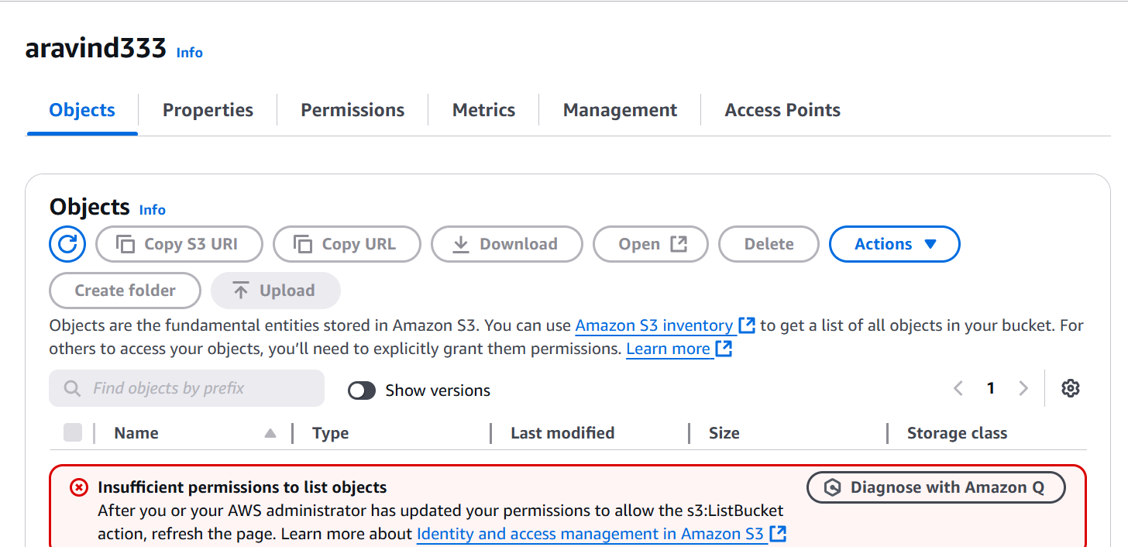*

*Setup lifecycle policies to automatically transition or delete objects based on specific criteria.*

*